# 1. Experiment equipment

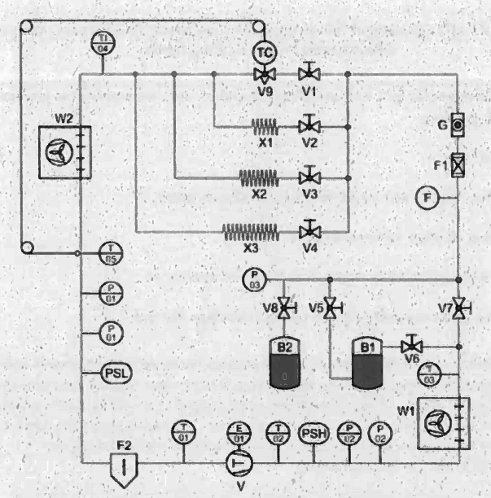

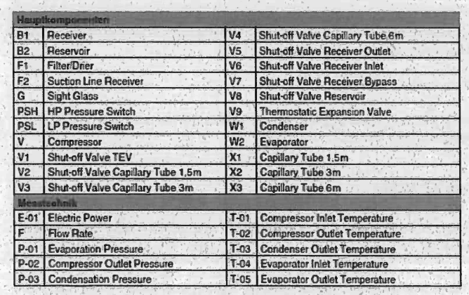

# 2. Experiment operation logic

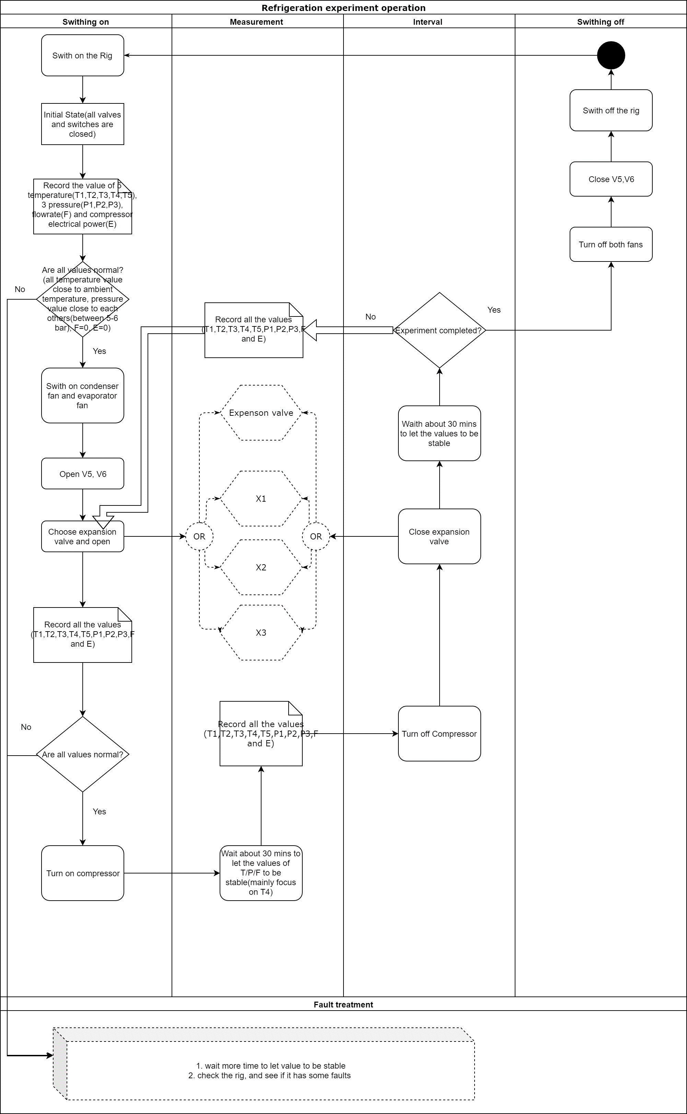

# 3. Statement in different periods of the experiment

1. **The initial state:**

* All valves are closed.
* The temperature of the initial state is the ambient temperature.
* The pressure of the initial state is the ambient pressure.
* Flowrate is 0
* E is 0

1. **Measurement state (after turning on the compressor)**

* The V5, V6, and one of the expansion valves is opened (V1 or V2 or V3 or V4), others are all closed
* T1 value decrease, T2 value increase, T3 value increase, T4 value decrease, T4 value decrease
* P1 valve decrease, P2 valve increase, P3 valve increase
* Flowrate is constant
* E is about 200w
* The time for measurement (Values of T/P/F/E become stable on the equipment) is about 30 mins.
* The specific value of T/P/F/E in the measurement is as the below table:



1. **Interval between two experiments state**

* The V5 and V6 are opened, others are all closed
* T1/ T2 / T3/ T4 /T5 values are gradually reaching to ambient temperature
* P1 /P2 /P3 values are gradually reaching to ambient pressure
* Flowrate is 0
* E is 0
* The time for returning the initial state (Values of T/P/F/E become stable on the equipment) is about 30 mins.
* The specific value of T/P/F/E for the interval state is as the below table:



1. **Switch off state**

* All valves are closed.
* The temperature of the initial state is the ambient temperature.
* The pressure of the initial state is the ambient pressure.
* Flowrate is 0
* E is 0

# 4. Experiment with safety controls that need to be in place

* The V7 and V8 valves should be closed all the time in the experiment.
* The valves of V1, V2, V3, and V4 should be fully opened in the experiment, and students can only choose one for one experiment at once.

The reason for fully opening is that the experiment results will be different if the valves open in different scales. To be specific, the experiment result of fully opened V1 is different from half-opened V1. The different results of the two experiments are seen in the green rows in the below table.



* Do not adjust any valve during the measurement.
* The gauges will fluctuate when taking the measurement. This is how real experiments behave, and not a sign that the apparatus is faulty.
* When the experiment is completed, the compressor must be turned off.
* Before switching off the rig, the temperature and pressure need to be settled for at least half an hour.
* The highest temperature for the compressor is about 86 ℃(according to the experiment in 2023.10.19-2023.10.20).
* The lowest temperature of the evaporator is about 4.9 ℃(according to the experiment in 2023.10.19-2023.10.20).
* The highest pressure of the compressor and condenser is about 14.3 bar (according to the experiment in 2023.10.19-2023.10.20).
* The lowest pressure of the evaporator is about 2.4 bar (according to the experiment in 2023.10.19-2023.10.20).